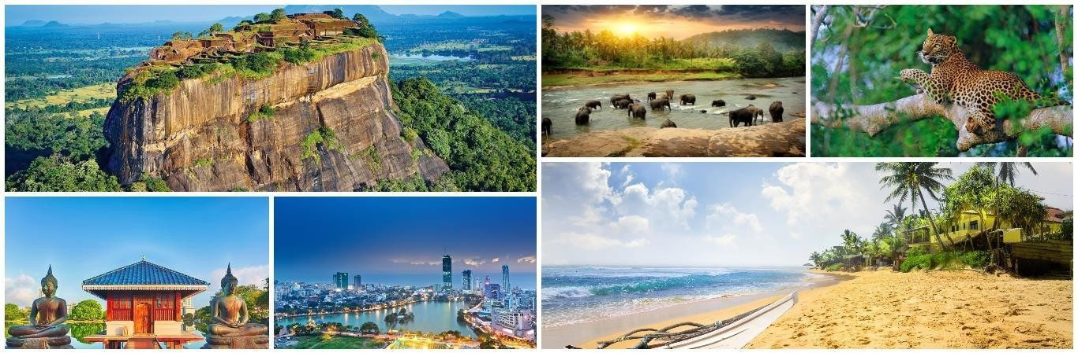

06th November 2024

Colombo - Sri Lanka

05Nights / 06Days

|  |  |  |
| --- | --- | --- |
| **TOUR HIGHLIGHTS** | | |
| **COUNTRY** | **DURATION** | **HIGHLIGHTS** |
| Colombo | 01 Night | City tour of Colombo, (BMICH,Old Parliament, Galle face, Independence Square, Town hall, Pettah, Fort, Gangarama Lake,  Lotus pond, Lotus Tower) Shopping at Odel and House of fashions |
| Kandy | 01 Night | Pinnawala Elephant Orphanage, Spice Garden, Temple of Tooth relic, Kandy Gem Museum and Cultural Dance Show |
| Nuwareliya | 01 Night | Peradeniya Botanical Garden, Ramboda Shri Bhaktha Hanuman Temple, Tea Plantation and factory, Ramboda Waterfalls, Gregory  Lake, Race Course, Golf Course, Seetha Amman Temple |
| Bentota | 02 Nights | St. Clair’s Falls. Devon Falls, Turtle Hatchery at Kosgoda, Balapitiya,  Boat Safari at Madu river, Water sports activities(all activities by Own) |

|  |  |
| --- | --- |
| **SIGHTSEEING FOR WHICH ENTRANCE FEE ARE INCLUDED** | |
| **COUNTRY** | **SIGHTSEEING** |
| Kandy | Pinnawala Elephant Orphanage, Temple of Tooth relic |
| Nuwareliya | Peradeniya Botanical Garden, Gregory park |
| Bentota | Madu River Boat Safari, Turtle Hatchery |

|  |  |  |  |
| --- | --- | --- | --- |
| **INTERNATIONAL FLIGHTS SUGGESTED** | | | |
| **Date** | **From** | **To** | **Flight Details** |
| 06th Nov 2024 | Bangalore | Colombo | 6E-1167 06NOV BLRCMB 1120 1255 |
| 11th Nov 2024 | Colombo | Bangalore | 6E-1168 11NOV CMBBLR 1355 1520 |

Flights are subject to availability and the fares may vary at the time of confirmation.

|  |  |
| --- | --- |
| **Report to Bangalore International Airport on Wednesday 06th November 2024** | |
| 08:20Hrs | Report to Bangalore International Airport. |
| 09:20Hrs | Check in for Indigo Airline 6E-1167 |
| 11:20Hrs | Departure by Indigo Airline 6E-1167 to Colombo |
| 12:55Hrs | Arrive Colombo international airport on **Wednesday 06th November 2024** |

# COLOMBO

## Day 01 – Wednesday 06th November 2024

Arrive Colombo airport by 6E-1167 at 13:05hrs,

Meet on arrival, welcome by our airport representative Transfer to Colombo

Lunch at Indian Restaurant

## Proceed to City tour of Colombo, (BMICH,Old Parliament, Galle face, Independence Square, Town hall, Pettah, Fort, Gangarama Lake, Lotus pond, Lotus Tower)

Check in to the Hotel

Dinner and Overnight Stay at Hotel in Colombo

**Meal Plan: Lunch | Dinner**

# COLOMBO - PINNAWALA - KANDY

## Day 02 – Thursday 07th November 2024

Breakfast at the Hotel Check out from Hotel Transfer to Kandy

## En route visit: Pinnawala Elephant Orphanage, Spice Garden,

Lunch at Indian Restaurant

## Proceed to Kandy city tour, Temple of Tooth relic, Gem Museum and Cultural Dance Show

Check in Hotel & Relax

Dinner and Overnight Stay at Hotel in Kandy

**Meal Plan: Breakfast | Lunch | Dinner**

# KANDY - NUWARELIYA

## Day 03 – Friday 08th November 2024

Breakfast at the Hotel

Proceed to Visit: **Peradeniya Botanical Garden**, Transfer to **Nuwareliya**

Lunch at Indian Restaurant

## En route visit: Ramboda Shri Bhaktha Hanuman Temple, Tea Plantation and factory, Ramboda Waterfalls.

Check in Hotel

Dinner and Overnight Stay at Hotel in Nuwareliya

**Meal Plan: Breakfast | Lunch | Dinner**

# NUWARELIYA - BENTOTA

## Day 04 – Saturday 09th November 2024

Breakfast at the Hotel

## Proceed to sightseeing in Nuwara Eliya, Gregory Lake, Race Course, Golf Course, Seetha Amman Temple

Transfer to Bentota

En route visit **St. Clair’s Falls. Devon Falls**

Lunch at Indian Restaurant Check in Hotel

Dinner and Overnight Stay at Hotel in Bentota

**Meal Plan: Breakfast | Lunch | Dinner**

# BENTOTA

## Day 05 – Sunday 10th November 2024

Breakfast at the Hotel

## Proceed to Visit: Turtle Hatchery at Kosgoda

**Transfer to Balapitiya, Boat Safari at Madu river, Water sports activities (all activities by Own)**

Lunch at Indian Restaurant

Dinner and Overnight Stay at Hotel in Bentota

**Meal Plan: Breakfast | Lunch | Dinner**

# BENTOTA - COLOMBO - DEPARTURE

## Day 06 – Monday 11th November 2024

Breakfast at the hotel Check out from Hotel

Transfer to Colombo Airport to board flight by 6E-1168 at 1355Hrs, Arrive Bangalore at 1520Hrs.

**Meal Plan: Breakfast**

# INDICATIVE LIST OF HOTELS

The list of hotels mentioned below is likely to be provided. However, Turnkey holidays reserve the right to provide alternate hotels that are like the ones mentioned below. The final hotel list may vary from the below for each group.

|  |  |  |  |  |  |
| --- | --- | --- | --- | --- | --- |
| **Destination** | **Number**  **of nights** | **Check in** | **Check out** | **4 Star Hotel** | **Room category** |
| Colombo | 01 | 06th Nov 2024 | 07th Nov 2024 | Fairway Hotel or similar | Deluxe room |
| Kandy | 01 | 07th Nov 2024 | 08th Nov 2024 | Randholee Resort or similar | Deluxe room |
| Nuwareliya | 01 | 08th Nov 2024 | 09th Nov 2024 | Araliya Red or similar | Deluxe room |
| Bentota | 02 | 09th Nov 2024 | 11th Nov 2024 | The Palms or similar | Deluxe room |

Any changes in the hotels are subject to availability at time of issuance Early check in and late checkout are subject to hotel policy

Hotel Check in and Check out Time

|  |  |
| --- | --- |
| Check In | 15:00 Hrs |
| Check Out | 11:00 Hrs |

# TOUR COST INCLUDING AIRFARE

|  |  |
| --- | --- |
| Minimum 04 Passengers Travelling together | Per Adult on Twin / Triple Sharing Basis (12+years) |
| **INR.71,900/- Per Adult** |

The above tour cost includes International air ticket cost of INR.23,100/- per person as on 12.09.2024. However, actual air ticket cost will be collected at the time of tour confirmation and ticketing.

## Please note:

Guest must produce PAN card for the payment of INR 49,900/- above in cash. Maximum cash that can be accepted towards this tour is INR 1,99,000/- only.

TCS of 5% in addition to the tour cost shall be collected and deposited towards the respective PAN of the remitter of the tour cost.

## TOUR COST INCLUSIONS:

Air ticket and airport tax from Bangalore and Return by Indigo Airlines or similar Arrival and Departure Airport transfers on private basis

05 Nights Accommodation at above mentioned hotels or similar Meal plan as per itinerary

Transportation by Air Conditioned Vehicle Service of English-Speaking Chauffeur Guide 500ML X 2 water bottle per person per day Applicable GST

## TOUR COST EXCLUDES:

Sri Lanka Visa

All kind of personal expenses such as tips, laundry, Telephone bills Water Sports activities cost

Optional, suggested, or unspecified activities Camera fee (still or movie)

Any other services which is mentioned under inclusions

## NOTE:

Rooms are subject to availability at the confirmation.

Early check in and late Check-Out is subject to availability and on extra cost. Passport should be valid for more than7months from the date of return journey

The exchange rate considered 1USD:-INR.85, however any escalation as to be absorbed by the clients themselves.